Tailwind CSS is an utility first framework which allows you to style your HTML pages without leaving your HTML file.

The simple explanation of this is that you will have to add some utility classes within the HTML tags., and you can design your pages easily by simply including these classes.

Tailwind site - > play cdn -> and add this script <script src="https://cdn.tailwindcss.com"></script> in head .

npm init

npm install vite

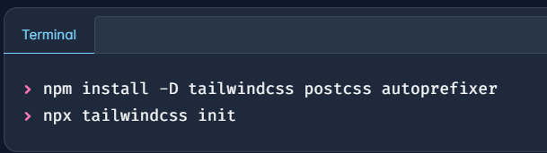

Best extention for css - Tailwind CSS Intelligence

